> outcome <- read.csv("outcome-of-care-measures.csv", colClasses = "character")

> head(outcome)

Provider.Number Hospital.Name Address.1 Address.2 Address.3 City State ZIP.Code

1 010001 SOUTHEAST ALABAMA MEDICAL CENTER 1108 ROSS CLARK CIRCLE DOTHAN AL 36301

2 010005 MARSHALL MEDICAL CENTER SOUTH 2505 U S HIGHWAY 431 NORTH BOAZ AL 35957

3 010006 ELIZA COFFEE MEMORIAL HOSPITAL 205 MARENGO STREET FLORENCE AL 35631

4 010007 MIZELL MEMORIAL HOSPITAL 702 N MAIN ST OPP AL 36467

5 010008 CRENSHAW COMMUNITY HOSPITAL 101 HOSPITAL CIRCLE LUVERNE AL 36049

6 010010 MARSHALL MEDICAL CENTER NORTH 8000 ALABAMA HIGHWAY 69 GUNTERSVILLE AL 35976

County.Name Phone.Number Hospital.30.Day.Death..Mortality..Rates.from.Heart.Attack

1 HOUSTON 3347938701 14.3

2 MARSHALL 2565938310 18.5

3 LAUDERDALE 2567688400 18.1

4 COVINGTON 3344933541 Not Available

5 CRENSHAW 3343353374 Not Available

6 MARSHALL 2565718000 Not Available

Comparison.to.U.S..Rate...Hospital.30.Day.Death..Mortality..Rates.from.Heart.Attack

1 No Different than U.S. National Rate

2 No Different than U.S. National Rate

3 No Different than U.S. National Rate

4 Number of Cases Too Small

5 Number of Cases Too Small

6 Number of Cases Too Small

Lower.Mortality.Estimate...Hospital.30.Day.Death..Mortality..Rates.from.Heart.Attack

1 12.1

2 14.7

3 14.8

4 Not Available

5 Not Available

6 Not Available

Upper.Mortality.Estimate...Hospital.30.Day.Death..Mortality..Rates.from.Heart.Attack

1 17.0

2 23.0

3 21.8

4 Not Available

5 Not Available

6 Not Available

Number.of.Patients...Hospital.30.Day.Death..Mortality..Rates.from.Heart.Attack

1 666

2 44

3 329

4 14

5 9

6 22

Footnote...Hospital.30.Day.Death..Mortality..Rates.from.Heart.Attack

1

2

3

4 number of cases is too small (fewer than 25) to reliably tell how well the hospital is performing

5 number of cases is too small (fewer than 25) to reliably tell how well the hospital is performing

6 number of cases is too small (fewer than 25) to reliably tell how well the hospital is performing

Hospital.30.Day.Death..Mortality..Rates.from.Heart.Failure

1 11.4

2 15.2

3 11.3

4 13.6

5 13.8

6 12.5

Comparison.to.U.S..Rate...Hospital.30.Day.Death..Mortality..Rates.from.Heart.Failure

1 No Different than U.S. National Rate

2 Worse than U.S. National Rate

3 No Different than U.S. National Rate

4 No Different than U.S. National Rate

5 No Different than U.S. National Rate

6 No Different than U.S. National Rate

Lower.Mortality.Estimate...Hospital.30.Day.Death..Mortality..Rates.from.Heart.Failure

1 9.5

2 12.2

3 9.1

4 10.0

5 9.9

6 9.9

Upper.Mortality.Estimate...Hospital.30.Day.Death..Mortality..Rates.from.Heart.Failure

1 13.7

2 18.8

3 13.9

4 18.2

5 18.7

6 15.6

Number.of.Patients...Hospital.30.Day.Death..Mortality..Rates.from.Heart.Failure

1 741

2 234

3 523

4 113

5 53

6 163

Footnote...Hospital.30.Day.Death..Mortality..Rates.from.Heart.Failure Hospital.30.Day.Death..Mortality..Rates.from.Pneumonia

1 10.9

2 13.9

3 13.4

4 14.9

5 15.8

6 8.7

Comparison.to.U.S..Rate...Hospital.30.Day.Death..Mortality..Rates.from.Pneumonia

1 No Different than U.S. National Rate

2 No Different than U.S. National Rate

3 No Different than U.S. National Rate

4 No Different than U.S. National Rate

5 No Different than U.S. National Rate

6 Better than U.S. National Rate

Lower.Mortality.Estimate...Hospital.30.Day.Death..Mortality..Rates.from.Pneumonia

1 8.6

2 11.3

3 11.2

4 11.6

5 11.4

6 6.8

Upper.Mortality.Estimate...Hospital.30.Day.Death..Mortality..Rates.from.Pneumonia

1 13.7

2 17.0

3 15.8

4 19.0

5 21.5

6 11.0

Number.of.Patients...Hospital.30.Day.Death..Mortality..Rates.from.Pneumonia

1 371

2 372

3 836

4 239

5 61

6 315

Footnote...Hospital.30.Day.Death..Mortality..Rates.from.Pneumonia Hospital.30.Day.Readmission.Rates.from.Heart.Attack

1 19.0

2 Not Available

3 17.8

4 Not Available

5 Not Available

6 Not Available

Comparison.to.U.S..Rate...Hospital.30.Day.Readmission.Rates.from.Heart.Attack

1 No Different than U.S. National Rate

2 Number of Cases Too Small

3 No Different than U.S. National Rate

4 Number of Cases Too Small

5 Number of Cases Too Small

6 Number of Cases Too Small

Lower.Readmission.Estimate...Hospital.30.Day.Readmission.Rates.from.Heart.Attack

1 16.6

2 Not Available

3 14.9

4 Not Available

5 Not Available

6 Not Available

Upper.Readmission.Estimate...Hospital.30.Day.Readmission.Rates.from.Heart.Attack

1 21.7

2 Not Available

3 21.5

4 Not Available

5 Not Available

6 Not Available

Number.of.Patients...Hospital.30.Day.Readmission.Rates.from.Heart.Attack

1 728

2 21

3 342

4 1

5 4

6 13

Footnote...Hospital.30.Day.Readmission.Rates.from.Heart.Attack

1

2 number of cases is too small (fewer than 25) to reliably tell how well the hospital is performing

3

4 number of cases is too small (fewer than 25) to reliably tell how well the hospital is performing

5 number of cases is too small (fewer than 25) to reliably tell how well the hospital is performing

6 number of cases is too small (fewer than 25) to reliably tell how well the hospital is performing

Hospital.30.Day.Readmission.Rates.from.Heart.Failure

1 23.7

2 22.5

3 19.8

4 27.1

5 24.7

6 23.9

Comparison.to.U.S..Rate...Hospital.30.Day.Readmission.Rates.from.Heart.Failure

1 No Different than U.S. National Rate

2 No Different than U.S. National Rate

3 Better than U.S. National Rate

4 No Different than U.S. National Rate

5 No Different than U.S. National Rate

6 No Different than U.S. National Rate

Lower.Readmission.Estimate...Hospital.30.Day.Readmission.Rates.from.Heart.Failure

1 21.3

2 19.2

3 17.2

4 22.4

5 19.9

6 20.1

Upper.Readmission.Estimate...Hospital.30.Day.Readmission.Rates.from.Heart.Failure

1 26.5

2 26.1

3 22.9

4 31.9

5 30.2

6 28.2

Number.of.Patients...Hospital.30.Day.Readmission.Rates.from.Heart.Failure

1 891

2 264

3 614

4 135

5 59

6 173

Footnote...Hospital.30.Day.Readmission.Rates.from.Heart.Failure Hospital.30.Day.Readmission.Rates.from.Pneumonia

1 17.1

2 17.6

3 16.9

4 19.4

5 18.0

6 18.7

Comparison.to.U.S..Rate...Hospital.30.Day.Readmission.Rates.from.Pneumonia

1 No Different than U.S. National Rate

2 No Different than U.S. National Rate

3 No Different than U.S. National Rate

4 No Different than U.S. National Rate

5 No Different than U.S. National Rate

6 No Different than U.S. National Rate

Lower.Readmission.Estimate...Hospital.30.Day.Readmission.Rates.from.Pneumonia

1 14.4

2 15.0

3 14.7

4 15.9

5 14.0

6 15.7

Upper.Readmission.Estimate...Hospital.30.Day.Readmission.Rates.from.Pneumonia

1 20.4

2 20.6

3 19.5

4 23.2

5 22.8

6 22.2

Number.of.Patients...Hospital.30.Day.Readmission.Rates.from.Pneumonia

1 400

2 374

3 842

4 254

5 56

6 326

Footnote...Hospital.30.Day.Readmission.Rates.from.Pneumonia

1

2

3

4

5

6

> outcome[, 11] <- as.numeric(outcome[, 11])

Warning message:

NAs introduced by coercion

> ## You may get a warning about NAs being introduced; that is okay

> hist(outcome[, 11])

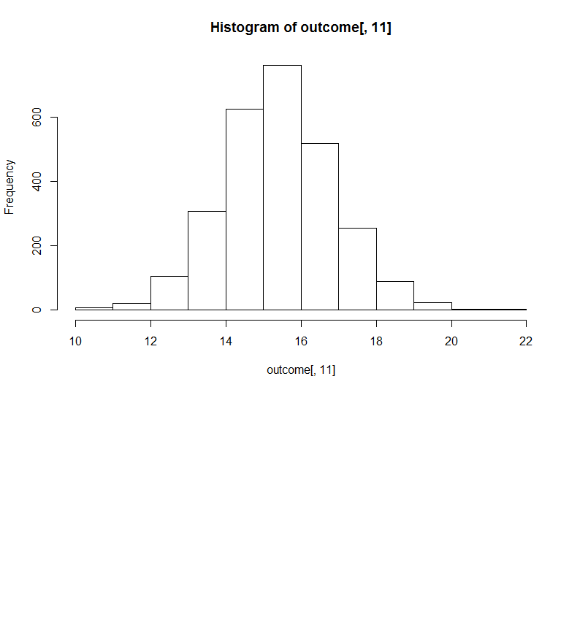

>

> best("TX", "heart attack")

[1] "CYPRESS FAIRBANKS MEDICAL CENTER"

Warning messages:

1: In which(as.numeric(outcome2[, colnum]) == min(as.numeric(outcome2[, :

NAs introduced by coercion

2: In which(as.numeric(outcome2[, colnum]) == min(as.numeric(outcome2[, :

NAs introduced by coercion

> best("TX", "heart failure")

[1] "FORT DUNCAN MEDICAL CENTER"

Warning messages:

1: In which(as.numeric(outcome2[, colnum]) == min(as.numeric(outcome2[, :

NAs introduced by coercion

2: In which(as.numeric(outcome2[, colnum]) == min(as.numeric(outcome2[, :

NAs introduced by coercion

> best("MD", "heart attack")

[1] "JOHNS HOPKINS HOSPITAL, THE"

Warning messages:

1: In which(as.numeric(outcome2[, colnum]) == min(as.numeric(outcome2[, :

NAs introduced by coercion

2: In which(as.numeric(outcome2[, colnum]) == min(as.numeric(outcome2[, :

NAs introduced by coercion

> best("MD", "pneumonia")

[1] "GREATER BALTIMORE MEDICAL CENTER"

> best("BB", "heart attack")

Error in best("BB", "heart attack") : invalid state

> best("NY", "hert attack")

[1] "invalid outcome"

Error in best("NY", "hert attack") : invalid outcome